July 2023
To the members and volunteers of Friends of Bald Rock,
We have appreciated the hard work, time, and energy that you have volunteered to us over the past (almost) two years! We need your continued support and hard work to continue moving forward with our goal of restoring Bald Rock HP. Recently, we have pivoted away from pressure washing the graffiti off the rock toward a more sustainable approach of restoring our beautiful and rare landform. The work that the Clemson University grad students did with their research project on Bald Rock HP helped us come to this decision. I thought I would take a minute to go into more detail about what this new approach will look like and why we decided to go in this direction.
While pressure washing the graffiti off the rock gave us immediate results, we realized that it was also taking off the dark patina layer on the rock surface. This patina layer is important for two reasons: it serves as a barrier between graffiti and the bare rock and, most importantly, it is the foundation (chemically and physically) for mosses, lichens, and some vascular plants (i.e., elf orpine) to grow and thrive on the rock face.
Rather than stripping the patina layer off, we decided that it would be more sustainable to encourage the establishment of it. Establishing the patina layer will protect the rock face from graffiti because the paint will erode faster (since it’s not attached to the porous bare rock). Paint that is sprayed on the rock will not be as noticeable because of the darkness of the patina, rather than the light grey color of the bare rock. Additionally, having this patina will encourage the growth of lichens and mosses on the rock face that will eventually cover up much of the rock, leaving less rock available to spray paint. Here is a great example of a granitic rock outcrop in Pickens that has the patina and is mostly covered in lichens and mosses:
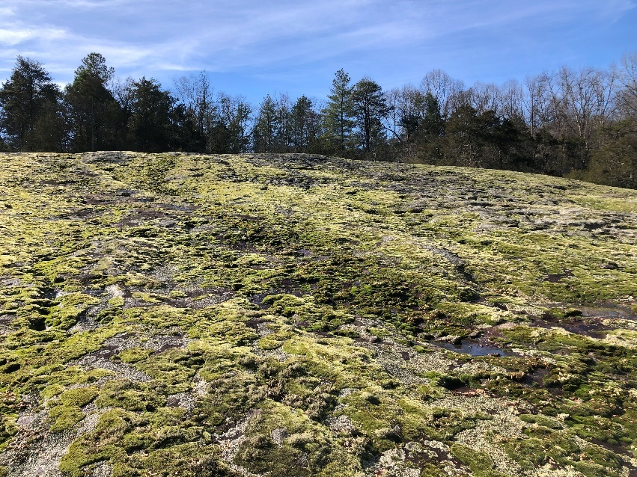
To help the patina establishment on Bald Rock HP, we will start by filling the shallow depressions with soil and, where appropriate, putting sticks and logs to “dam up” the depression. The dam will keep the soil in place. When it rains, the water runoff from these depressions will carry soil particles with it as it runs downslope. When the water dries, it will leave behind a layer of dirt on the rock, eventually forming the patina. We expect the soil filled depressions will also recruit the establishment of annuals, perennials, shrubs and small trees, creating vegetative islands among the rock face. See this interesting article about plant life on granitic outcrops Plant Life on Granite Outcrops - New Georgia Encyclopedia. Here is an example of rock moss, elf orpine, and sandwort on a similar granitic outcrop at Glassy Mountain Heritage Preserve:
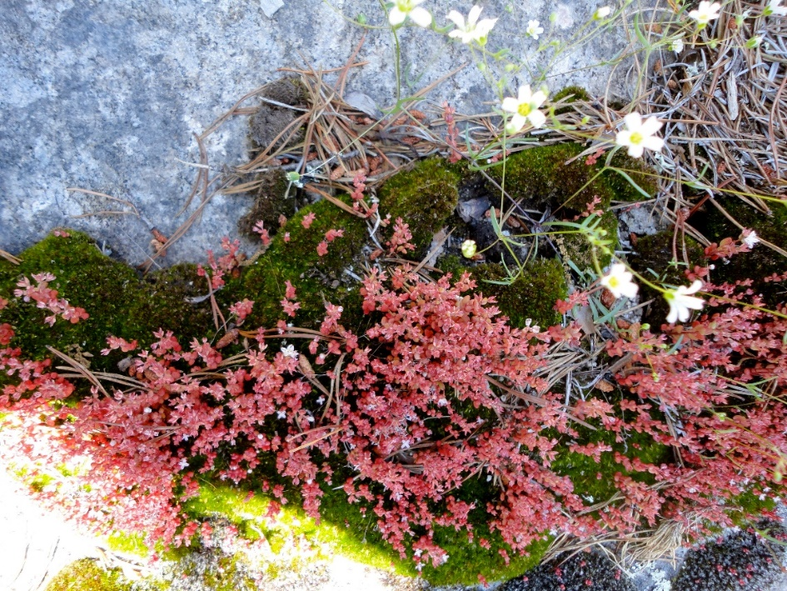

We will monitor the depressions that we fill to measure their progress. In the fall and/or spring we will plan on doing some transplanting to help establish vegetation in the soil-filled depressions.
In the future, we hope this restoration work will deter vandalism, return Bald Rock to a beautiful mosaic of diverse vegetation, and add value to the visitor’s experience.
I sincerely appreciate the work that the members and volunteers of Friends of Bald Rock have done to help DNR restore, preserve, and protect Bald Rock HP. We hope that you all continue to volunteer and assist us in reaching our goal to restore Bald Rock!
Thank you,
Austen Attaway
SCDNR Heritage Preserve Manager

